Purpose at Work
National Disability Services

Right on Board: Practice Governance for Disability Service Providers
Governing and Managing for Human Rights, Quality and Safeguarding

Purpose at Work, in partnership with National Disability Services, presents Right on Board: a program for Boards and Executive Teams of disability service providers on practice governance.
Practice governance should be an integrated component of the corporate governance of disability service providers. It ensures that everyone – from frontline staff to managers and board members – is accountable to the people supported and the community for assuring the delivery of safe, effective and high-quality services.
Practice governance systems provide confidence to the community and the organisation that systems are in place to deliver safe and high-quality disability supports. Practice governance is related to the concept of ‘clinical governance’ but recognises that, for most disability service providers, the majority of services are not clinical in nature.
Right on Board also answers the need as highlighted by the Disability Royal Commission for greater awareness of the United Nations Convention on the Rights of Persons with Disabilities, as well as the strengthened governance and management of quality and safeguarding.

Get Right on Board
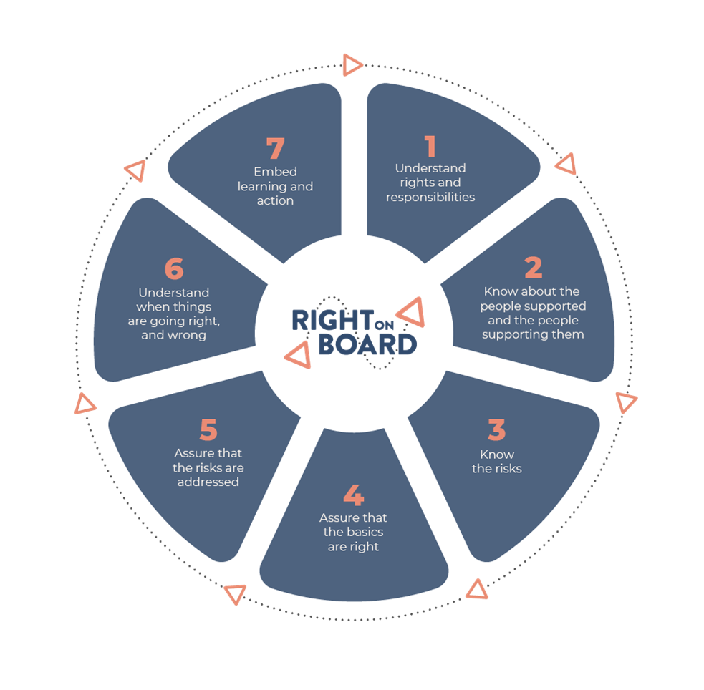
Your Board and Executive Team will gain a deeper understanding of:
- The human rights approach and the legislative context, including key provisions of the UN Convention that affect service design and delivery
- The recommendations of the Royal Commission about common service types and practices
- The key concepts around practice governance, quality and safeguarding impacting the entire sector, as well as the key challenges for your own organisation
- The potential areas for strengthening your organisation’s governance.
As a result, your organisation will have a better understanding of the standards that people using disability services should expect and will be better prepared to respond to the Royal Commission’s recommendations.

The Right on Board program
Purpose at Work offers Right on Board in three formats.

Option A: In-house workshop
- An intake interview with the CEO or delegate
- Delivery of the workshop
- A comprehensive workbook for you to provide to each participant
The workshop can be delivered in-person or online.
- If delivered in person, it is usually delivered over 7.5 hours. Some organisations prefer to have the program delivered over two days and this can be arranged at additional cost.
- For online delivery, it is usually delivered as 6 hours (3 x 2 hour workshops), delivered one week apart. If delivered online, it is usually delivered with two presenters, to ensure the best possible experience for participants.

Option B: The public program
The online public program is offered by NDS Learning and Development, and you can find the next dates on the NDS website. This program includes:
- 3 x 2 hour workshops, delivered one week apart, in the late afternoon for the convenience of board members, and
- A comprehensive electronic workbook provided to each participant.
The public program is also offered on occasions as a face-to-face workshop: see the NDS website.

Option C: The Full Program
- Interviews with key informants: the CEO, the COO, the Executive responsible for quality, and the Chair of the Board’s Quality & Safeguarding Committee (however these roles are titled in your organisation)
- Desktop review of 20 to 30 key organisational documents relevant to practice governance, from the perspective of human rights, quality and safeguarding
- A written report from the interviews and desktop review on what the organisation does well, with recommendations on what could be improved
- Delivery of the workshop, tailored to the unique circumstances of your organisation
- A comprehensive workbook for you to provide to each participant, and
- Post-workshop implementation assistance (of up to half a day).
The workshop can be delivered in-person or online.
- If delivered in person, it is usually delivered over 7.5 hours. Some organisations prefer to have the program delivered over two days and this can be arranged at additional cost.
- For online delivery, it is usually delivered in 6 hours (3 blocks x 2 hours, delivered one week apart). If delivered online, it is usually delivered with two presenters, to ensure the best possible experience for participants.
Supplementary services are available on request and will be quoted separately, e.g. developing policies, risk appetite statements, and Key Performance Indicators; consulting on implementation; or observing a meeting of the Quality and Safeguarding Sub-Committee of the Board.

Our consultants
Alan Hough, PhD, GAICD. Alan combines expertise in governance with extensive practical knowledge of quality and safeguarding in disability service provision. He presents regularly at sector conferences. Together with Professor Christine Bigby, Alan is co-editor of Disability Practice: Safeguarding Quality Service Delivery published by Palgrave. Alan is a person living with a disability.
Alex Carbonetti. Alex has twenty years of experience in the disability sector. She consults with disability service providers to develop quality systems and contemporary, person-centred practice to meet the requirements of the NDIS Practice Standards. Alex has been a quality auditor for nine years and conducts quality audits across a number of standards including the Practice Standards.
Gilbert Kruidenier, MSc Organisational Culture and Change, GAICD. Gilbert has wide-ranging consulting experience and has been engaged with NDS in the ACT and Victoria, on topics such as strategy, change, workforce and governance. Gilbert has been a speaker at the NDS Victoria State Conference and is the author of the NDS interactive resource Fundamentals for Boards.
John McKenna. John has more than sixty years of living experience of having a physical disability, and has worked as an empowerment advocate for over thirty years. He has presented to national and international audiences, and is a media host and producer. John serves on numerous boards that focus on disability, aged care, and health services.

Terms
The workbook is supplied in electronic format, for copying and distribution by the client. If you prefer, we can arrange photocopying and collation at cost.

Questions?
Contact us to secure your booking by emailing Alan Hough: alan@purposeatwork.com.au or phone 0407 132 848.

